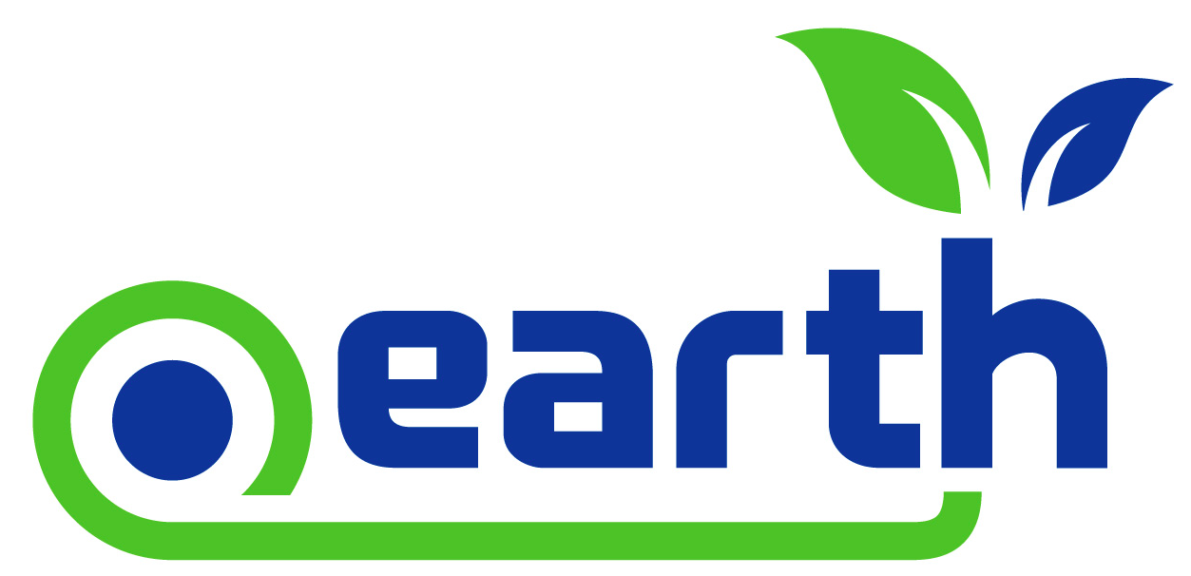

.Earth Domain Web Copy and Positioning
Writing web copy is often much easier said than done. Fortunately, we are offering the proposed content below to help you create the best possible marketing pages for your .Earth domain sales and promotions.
Landing Page Copy:
Please use our copy in total, or mix and match, to create your ideal .Earth landing page today!
The .Earth domain creates a unique place that unites like minds—whether it be brands or individuals—and allows them to promote their passions, causes, businesses, brands or stories for the overall betterment of life for all.
This special domain is all about uniting and establishing cooperative relationships between individuals and organizations that wish to show their support for making Earth a better place.
The .Earth domain also creates a safe place on the Internet, and allows organizations to elevate their brands to enhance overall awareness, revenue generation, expand their memberships, and grow their donor bases.
Embraced by geospatial companies, trade organizations, travel companies, engineering firms, new technology innovators, authors, artists, and much more, the .Earth domain “tribe” is large and growing -- and expands well beyond green organizations.
Suggested Headlines:
Make your .Earth search results and landing pages standout with compelling headlines.
- Unite in the Name of Earth: A Domain That Promotes Your Passions
- Become Part of the Growing .Earth Domain “Tribe”
- Promote the Betterment of Life for All With a .Earth Domain
- The .Earth Domain: Going Way Beyond Being “Green”
- Become a Planet Innovator With a .Earth Domain
- Elevate Your Brand to New Heights with a .Earth Domain

