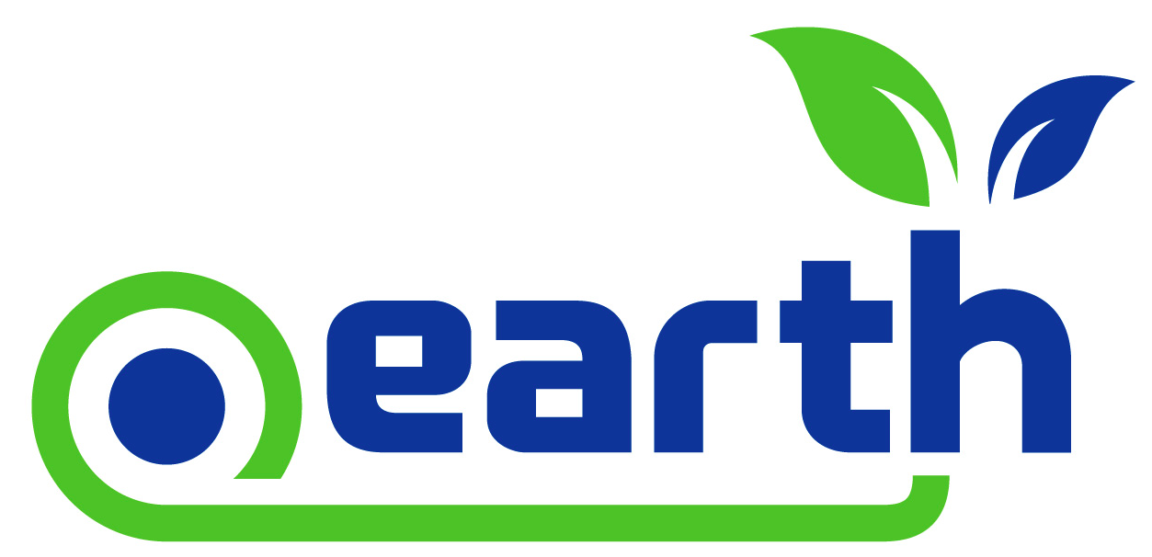

Benefits of a .Earth Domain
Articulating the true value and benefits of a .Earth domain to your customers and end-users is paramount. This is why we have compiled that following list of top seven benefits of a .Earth domain for you to re-purpose anyway you like!
The Seven Key Benefits of a .Earth Domain:
7) A .Earth Domain is a Platform: It allows all environmentally conscious citizens to share their voice about enriching life on Earth.
6) More Meaningful Than .com: Brand yourself “Right of the Dot,” and expand beyond the traditional “dot com” or “dot net.” A .Earth domain extension is a simple and highly effective way of letting everyone know that your organization’s mission is to save the planet.
5) Make “Earth” Part of Your Company Name: Consider changing your branding to include “Earth” in your organization or campaign’s name. Catalog.Earth and Access.Earth are prime examples of organizations that are effectively using the .Earth domain name as part of their overall brand.
4) Share Your Passion: The .Earth domain reinforces the passion that many organizations and individuals have for the planet.
3) Cost-Effective: Securing a new .Earth domain extension will not break the bank – even for premium names.
2) Trust in You: .Earth domain names convey a higher level of trust to your customers, partners, and constituents when they are seeking out information about your organization.
1) Put Earth First (Always): In this day and age, it’s always good to remind ourselves that the Earth does come first. Show your audience.

